***Name : M. Safi - Ur - Rehman***

***REG NO : Sp24-BSE-083***

***Section : B***

***DSA***

***Dr. Tahir Maqsood***

***Semester project report***

***Single member group.***

***Introduction:***

This is an amazing display of the game world.

This project is named Game Saga. It consists of two amazing games with fabulous graphics and display. The games are:

1. Memory Card Game
2. Tic-Tac-Toe Game

The main window shows which game to play. On clicking that option, respective game would display.

***Features:***

***Memory Card Game:***

In the case of the memory game you have given option that you want to play on easy mode or hard mode. A player gets a point on matching a successful pair. Time is running and I have all the track of the moves. At the it shows how much time and moves are taken to complete the game. A user can undo his previous move with the UNDO button given below.

On easy mode it’s a combination of 4x4, there would be 4 rows and 4 columns consisting of 16 total entities that consist of total of 8 pairs.

On hard mode it’s a combination of 6x6, there would be 6 rows and 6 columns consisting of 32 total entities that consist of total of 16 pairs.

***Tic-Tac-Toe Game:***

In the case of Tic tac toe game, it’s a fabulous display of graphics. It’s a 2 players game one is assigned O and second is assigned X. If a player matches its three signs consecutively the color changes and the player wins the game. A user can undo his previous move with the UNDO button given below.

***Outputs Screenshots:***

***Main display of game saga:***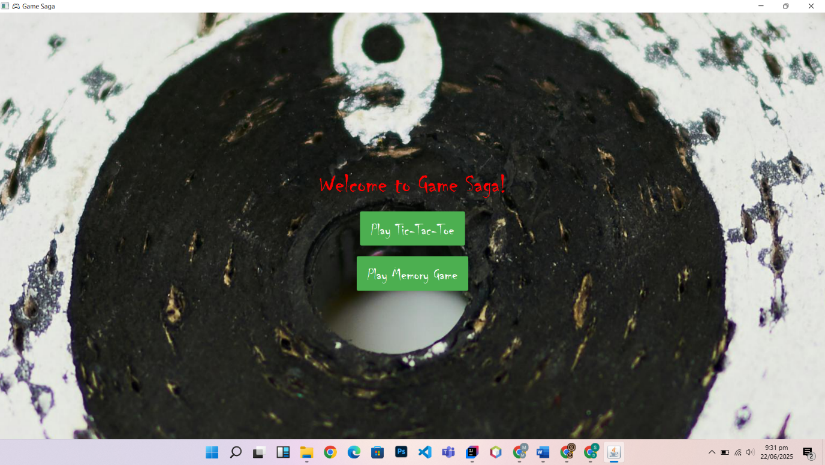

***Tic tac toe game:***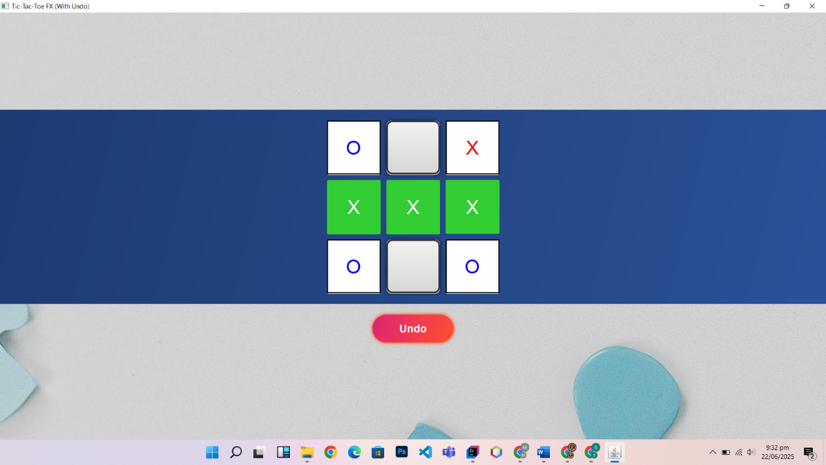

***Memory game:***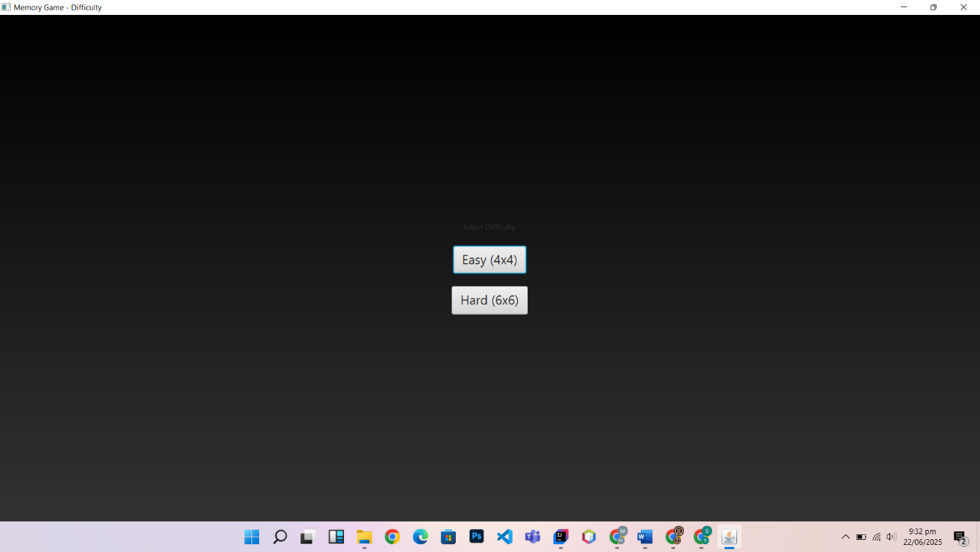

***Difficulty 4x4:***

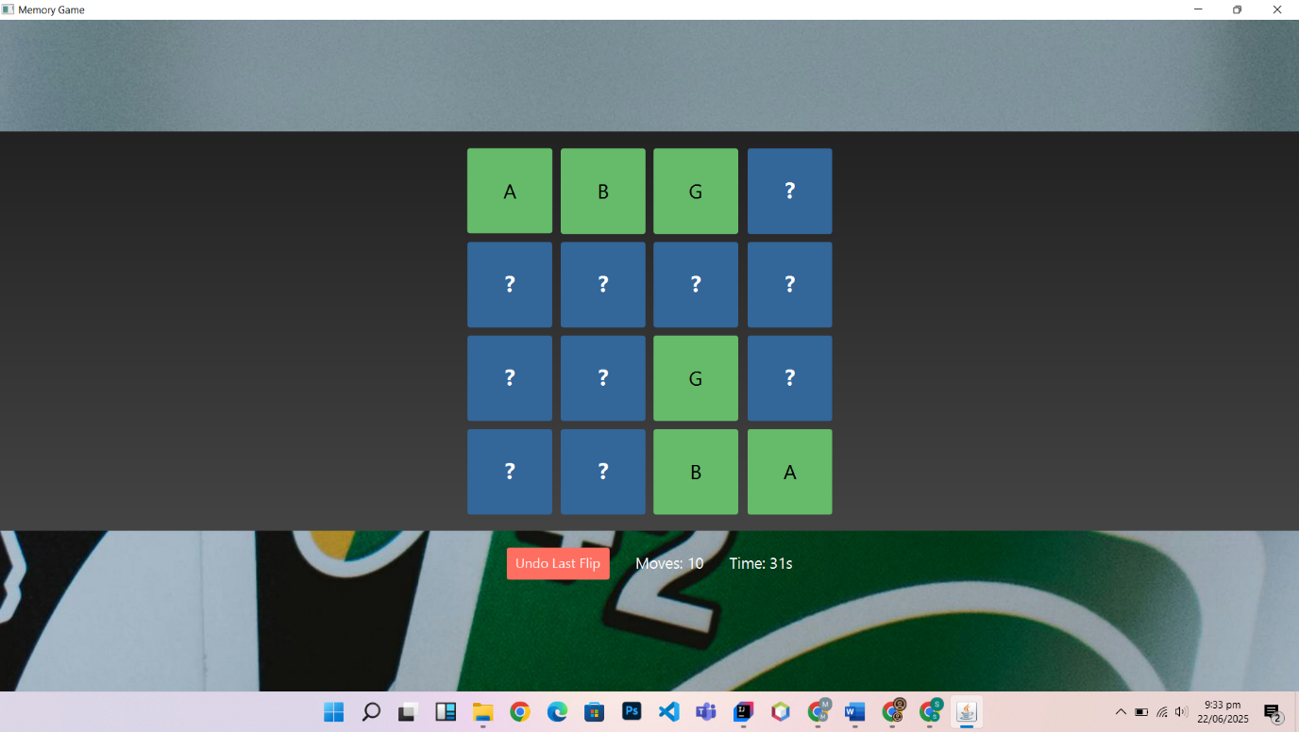

***Track of highest scores:***

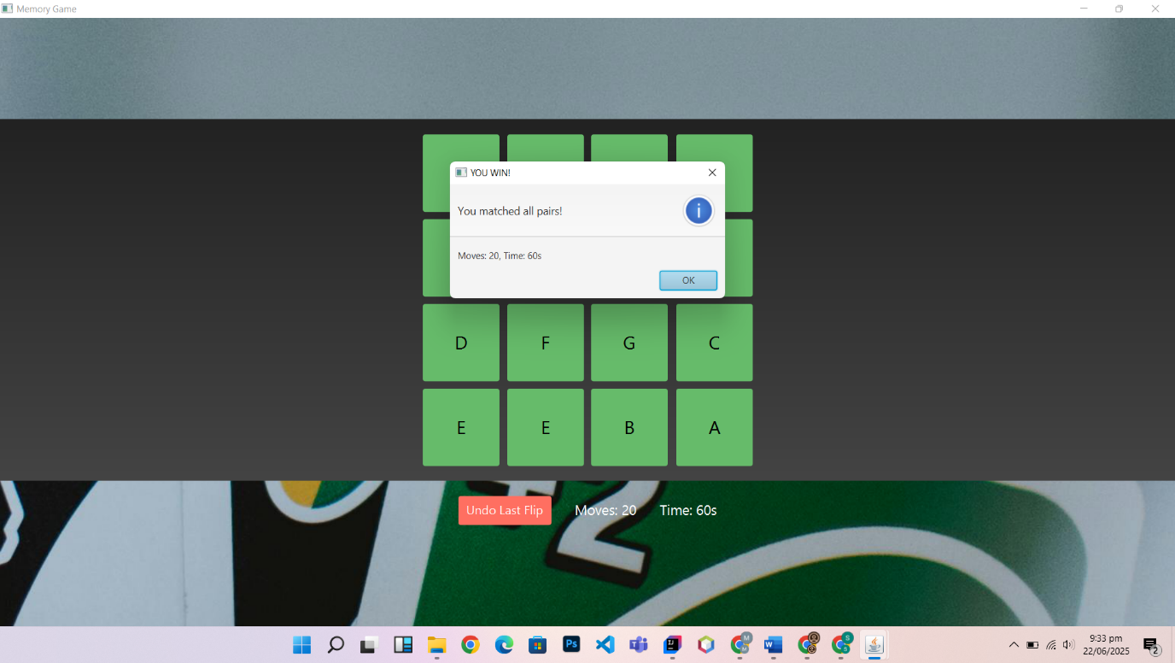

***Difficulty 6x6:***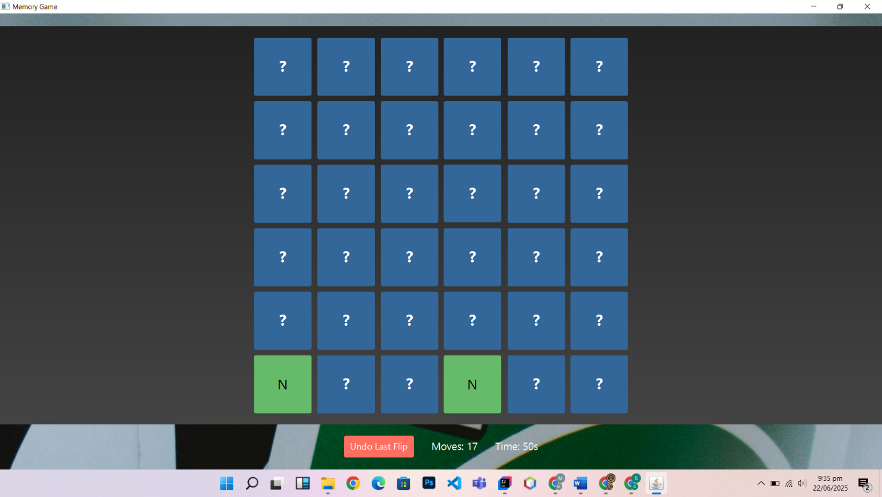

***Conclusions and Findings:***

1. **User Interface Design**: The application has a visually appealing user interface with a background image and styled buttons. The use of JavaFX allows for a responsive design that can adapt to different screen sizes.
2. **Game Logic**: The game logic for both Tic-Tac-Toe and the Memory Game is well-implemented. The Tic-Tac-Toe game includes an undo feature, which enhances user experience by allowing players to revert their last move.
3. **Code Structure**: The code is organized into separate classes for each game, which promotes modularity and maintainability. The use of a stack for undo functionality in Tic-Tac-Toe and a custom stack for the Memory Game is a good design choice.
4. **Event Handling**: The application effectively uses event handling to manage user interactions, such as button clicks for game moves and undo actions.
5. **Game Difficulty**: The Memory Game allows users to select difficulty levels, which adds an element of customization and caters to different skill levels.

***Challenges Faced:***

1. **Image Handling**: Managing file paths for images can be challenging, especially when deploying the application on different systems. Hardcoding paths may lead to issues if the directory structure changes.
2. **Game State Management**: Ensuring that the game state is correctly managed, especially with the undo functionality, can be complex. It requires careful tracking of the game board and user actions.
3. **Timer Implementation**: Implementing a timer for the Memory Game adds complexity, especially in ensuring it starts and stops correctly based on game events.
4. **User Experience**: Balancing game difficulty and ensuring that the games are engaging without being frustrating can be challenging. Playtesting is essential to find the right balance.
5. **Error Handling**: The application could benefit from more robust error handling, especially when dealing with file I/O operations and user inputs.

***Potential Future Enhancements***

1. **Game Statistics**: Implement a feature to track player statistics, such as win/loss records, average time taken to complete games, and total moves made. This could enhance user engagement.
2. **Multiplayer Mode**: Consider adding a multiplayer mode for Tic-Tac-Toe, allowing two players to compete against each other on the same device or over a network.
3. **AI Opponent**: For Tic-Tac-Toe, implementing an AI opponent could provide a challenging single-player experience. The AI could use algorithms like Minimax to make optimal moves.
4. **Enhanced Graphics and Animations**: Adding more animations and visual effects could improve the overall user experience. For example, animations for winning moves or card flips in the Memory Game.
5. **Sound Effects and Music**: Incorporating sound effects for button clicks, winning moves, and background music could enhance the gaming experience.
6. **Mobile Compatibility**: Consider adapting the application for mobile devices, which would require a responsive design and touch controls.
7. **Additional Games**: Expanding the game library by adding more games could attract a wider audience. Consider classic games like Connect Four, Snake, or a simple platformer.
8. **User Profiles**: Allow users to create profiles to save their progress and preferences, making the application more personalized.
9. **Accessibility Features**: Implement features to make the game more accessible, such as colorblind modes, text-to-speech for game instructions, and adjustable font sizes.